EX No:1A | SETTING UP PYTHON ENVIRONMENT AND LIBRARIES – JUPYTER NOTEBOOK

Aim:

To install Python, configure Jupyter Notebook, understand the notebook environment, execute Python programs, create Markdown cells, and use basic Jupyter Notebook features for Data Analytics applications.

Algorithm:
Algorithm 1: Installing Python
- Download Python from python.org
- Run the installer
- Select "Add Python to PATH"
- Click Install Now
- Verify installation using: python --version
- Observe installed Python version

Algorithm 2: Installing Jupyter Notebook
- Open Command Prompt
- Install Jupyter pip install notebook
- Launch Jupyter Notebook jupyter notebook
- Browser automatically opens Notebook Dashboard.

Algorithm 3: Creating a Notebook
- Open Jupyter Dashboard
- Select New → Python 3
- Create Notebook
- Rename Notebook
- Create Code and Markdown Cells
- Execute cells using Shift + Enter

Program:
Program 1 — Simple Python Program print("Welcome to Data Analytics Lab") Output: Welcome to Data Analytics Lab

Program 2 — Arithmetic Operations
a = 20
b = 10
print("Addition =", a + b) print("Subtraction =", a - b) print("Multiplication =", a * b) print("Division
=", a / b) Output:
Addition = 30
Subtraction = 10
Multiplication = 200
Division = 2.0

Program 3 — Display Student Details
name = "John" dept = "AI&DS"
cgpa = 8.9 print("Name:", name)

print("Department:", dept) print("CGPA:", cgpa) Output:
Name: John Department:
AI&DS CGPA:
8.9

Program 4 — Creating Markdown Cell

Data Analytics Lab ## Experiment 1 ### Jupyter
Notebook Then press
Shift + Enter.

Program 5 — Using NumPy Library
import numpy as np
a = np.array([10, 20, 30, 40, 50])
print(a)
print("Mean =", np.mean(a))
print("Sum =", np.sum(a))

Output:
[10 20 30 40 50]
Mean = 30.0
Sum = 150

Program 6 — Using Pandas Library
import pandas as pd data = {
'Name': ['John', 'David',
'Alex'], 'Marks': [85, 90, 95]
}
df = pd.DataFrame(data)

Program 7 — Using Matplotlib Library

import matplotlib.pyplot as plt x = [1, 2, 3, 4, 5]
y = [10, 20, 15, 25, 30]
plt.plot(x, y) plt.title("Sample Line Graph") plt.xlabel("X Axis") plt.ylabel("Y
Axis") plt.show()

Output:
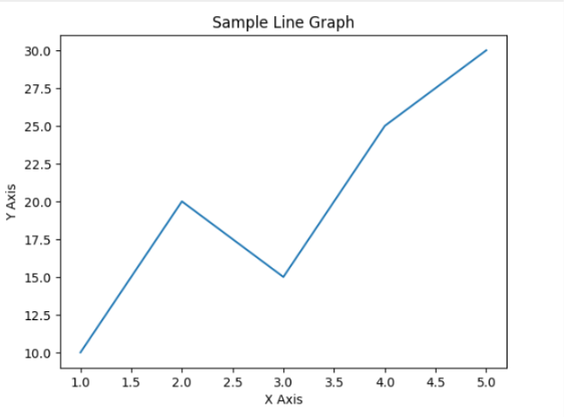

Result:

EXPT NO:1B | SPOTIFY TRACKS SYSTEM USING MACHINE LEARNING

AIM:
To perform Exploratory Data Analysis (EDA) on the Students Performance dataset by examining its structure, dimensions, data types, statistical characteristics, missing values, gender-wise and group-wise distributions, correlations among numerical attributes, and exporting the dataset into different file formats.
PROCEDURE:
1. Import the required libraries such as Pandas, OS, and Matplotlib.
2. Load the Students Performance CSV dataset using Pandas.
3. Display the dataset shape, column names, and data types.
4. Display the first five and last five records.
5. Generate descriptive statistical information for numerical attributes.
6. Identify the number of missing values in each column.
7. Find the distribution of students based on gender.
8. Analyze the distribution of race/ethnicity groups.
9. Analyze the distribution of parental education levels.
10. Analyze the distribution of test preparation course.
11. Generate the correlation matrix for numerical attributes.
12. Export the dataset into CSV, Excel, and JSON formats.
13. Display a confirmation message after successful file creation.

CODE:
import os
import pandas as pd
import matplotlib.pyplot as plt
# Load dataset
file_path = "StudentsPerformance.csv"
df = pd.read_csv(file_path)
print("Dataset loaded successfully!")
# First 5 records
print("\nFirst 5 rows:")
display(df.head())
# Last 5 records
print("\nLast 5 rows:")
display(df.tail())
# Dataset information
print("\nDataset Information:")
df.info()
# Descriptive statistics
print("\nDescriptive Statistics:")
display(df.describe())
# Missing values
print("\nMissing Values:")
display(df.isnull().sum())

# Gender distribution
print("\nGender Distribution:")
display(df["gender"].value_counts())
# Race/Ethnicity distribution
print("\nRace/Ethnicity Distribution:")
display(df["race/ethnicity"].value_counts())
# Parental Level of Education
print("\nParental Level of Education:")
display(df["parental level of education"].value_counts())
# Test Preparation Course
print("\nTest Preparation Course:")
display(df["test preparation course"].value_counts())
# Correlation
print("\nCorrelation Matrix:")
display(df.corr(numeric_only=True))
# Export files
df.to_csv("students_performance.csv", index=False)
df.to_excel("students_performance.xlsx", index=False)
df.to_json("students_performance.json", orient="records", indent=4)
print("\nCSV, Excel and JSON files created successfully.")

OUTPUT:
gender | race/ethnicity | parental level of education | lunch | test preparation course | math score | reading score | writing score
female | group B | bachelor's degree | standard | none | 72 | 72 | 74
female | group C | some college | standard | completed | 69 | 90 | 88
female | group B | master's degree | standard | none | 90 | 95 | 93
male | group A | associate's degree | free/reduced | none | 47 | 57 | 44
male | group C | some college | standard | none | 76 | 78 | 75

OUTPUT 2 — Missing-Value Analysis
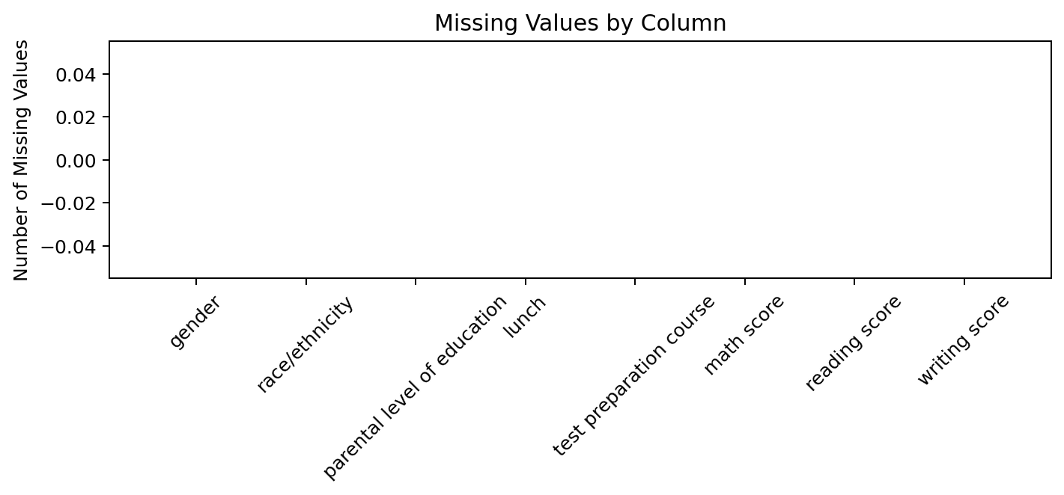
OUTPUT 3 — Race/Ethnicity Distribution
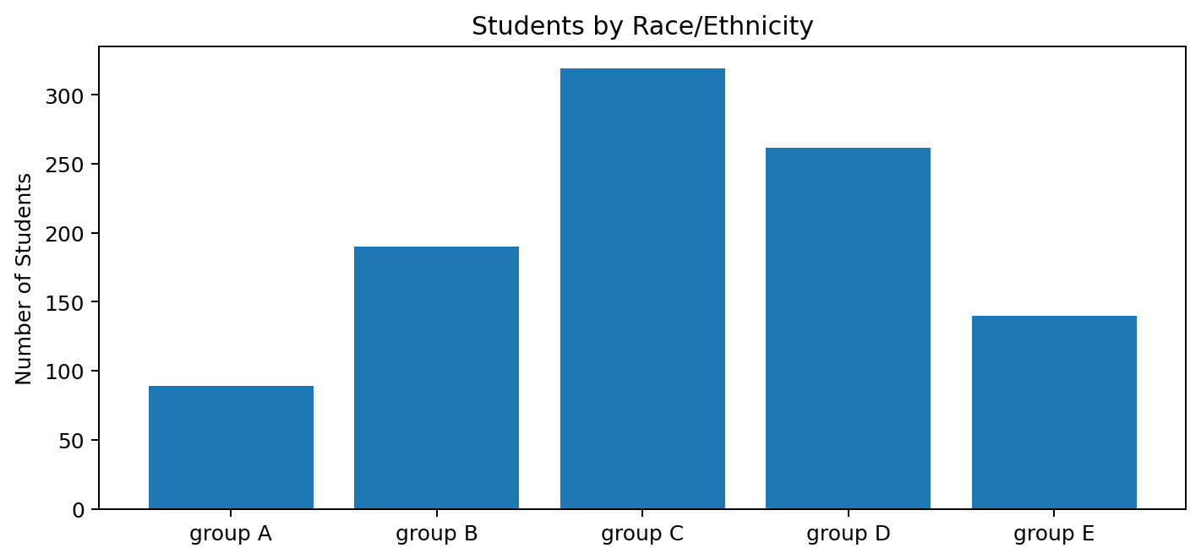

Analysis completed successfully!
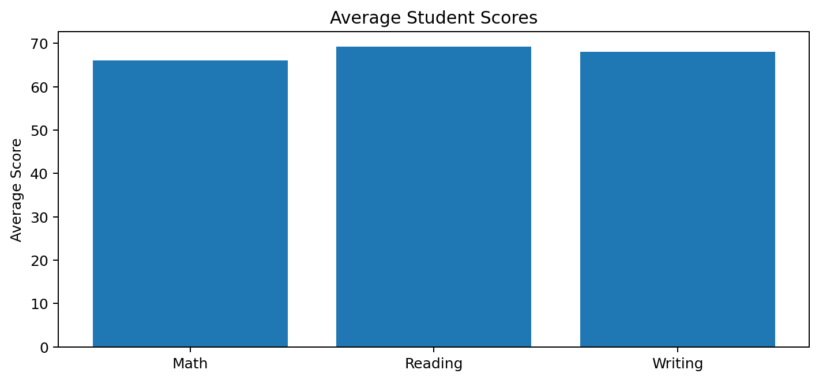
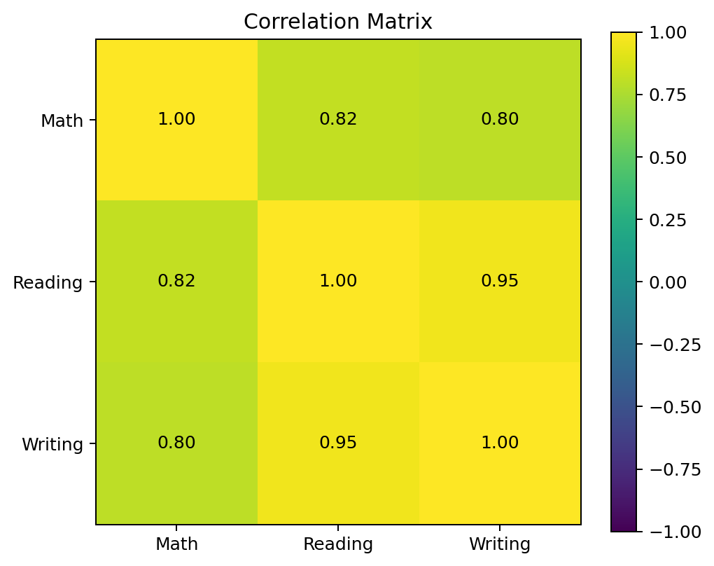
Result:
The Students Performance dataset was loaded and analyzed successfully. The required exploratory data analysis, statistical analysis, categorical distribution analysis, correlation analysis, and file export operations were completed successfully.

